Allegato 2b
Compatibilità Servizio di Lancio

TABLE OF CONTENTS

1 APPLICABLE AND REFERENCE DOCUMENTS 4
1.1 REFERENCE DOCUMENTS 4
1.2 GLOSSARY OF ACRONYMS AND ABBREVIATIONS 5
2 INTRODUCTION 7
3 Hosted Payload Form Factor 8
4 General Hosted Payload Requirements 9
4.1 Physical Requirements 9
4.2 Structural Requirements 14
4.3 Mission Requirements 15
4.4 Operation Requirements 17
4.5 Software Requirements 19
4.6 Electrical, Power and Data Requirements 20
4.7 Environmental Requirements 23
4.8 Verification Requirements 24
4.9 Product Assurance Requirements 27
5 Hosted Payload Class 33
5.1 Radiation and Shielding 34
5.2 Power Generation and Management 34
5.3 Attitude Control 34
5.4 Communications 34
5.5 Artificial Intelligence 34
5.6 EEE Components and On-board Sensors 35
5.7 Imaging Technologies 35
5.8 Materials 35
6 CONCLUSIONS 36
Annex 1. Vibration Test Levels 37
Annex “5.5” Main Events 40

APPLICABLE AND REFERENCE DOCUMENTS

REFERENCE DOCUMENTS
Documents referenced in the following text, are identified by [R.D.x], where “x” indicates the actual document, from the list in Table 1.

RD# | Title | Doc No.
 | CubeSat Design Specification (1U – 12U) | CP-CDS-R14.1 REV 14.1
 | (2b1) Payload Forbidden And Restricted Materials List | LST-000232
 | Thermal vacuum outgassing test for the screening of space materials (15 November 2008) | ECSS-Q-ST-70-02C
 | Rideshare_Payload_Users_Guide - SpaceX | Version No. according to selected mission
 | ECSS-E-ST-10-03C
 | ECSS-E-HB-32-23A
 | ECSS-Q-ST-20-08C
 | System engineering general requirements | ECSS-E-ST-10C
 | Quality assurance | ECSS-Q-ST-20C
 | (2b2) Payload Declared Materials List (PDML) Template | TMP-000339
 | (2b3) Payload Declared Processes List (PDPL) Template | TMP-000340
 | Compatibilità col Servizio di lancio | Questo documento
 | Structural design and verification of pressurized hardware | ECSS-E-ST-32-02C
Table 1 - Reference documents

GLOSSARY OF ACRONYMS AND ABBREVIATIONS
Acronym | Description
APE | Attitude Pointing Error
AKE | Attitude Knowledge Error
C | Compliant
CIG | Codice identificativo di gara
CS | CubeSat
CUP | Codice unico di progetto
CVCM | Collected Volatile Condensable Material
DEL | Deliverable
EEE | Electrical Electronic Electromechanical
EM | Engineering Model
FM | Flight Model
FMR | Final Mission Review
HP | Hosted Payload
HWIL | HardWare In the Loop
HPP | Hosted Payload Provider
ION | In Orbit Now
IOD | In Orbit Demonstration
IOV | In Orbit Validation
LEO | Low Earth Orbit
LTAN | Local Times of Ascending Node
N/A | Not Applicable
NC | Non-Compliant
OBCP | On Board Computer Procedure
OPS | Operations
PA | Product Assurance
PC | Partially Compliant
PLD | Payload
RBF | Remove Before Flight
RF | Radio Frequency
RLM | Recovered Mass Loss
SCV | Satellite Carrier Vessel
SSO | Sun Synchronous Orbit
TS | Technical Specifications
TT&C | Telemetry Tracking and Command
U | CubeSat Unit
VSFB | Vandenberg Space Force Base
Table 2 - Acronyms and abbreviation

INTRODUCTION
The purpose of this document, is to define the technical requirements that the Hosted Payload Provider (HPP) shall comply to ensure the compatibility with the standard launcher service identified by ASI as part of In-Orbit Demonstration / In-Orbit Validation (IOD/IOV) missions in Low Earth Orbit (LEO). These missions will be conducted by D-Orbit with its ION platform and will utilize the launch service provided by the Space X - Falcon 9.
In the "Compliance" column, the HPP shall indicate its level of compliance with each requirement using the following codes:
- C (Compliant): the requirement is fully met;
- PC (Partially Compliant): the requirement is partially met;
- NC (Non-Compliant): the requirement is not met.
In the "Value" column, the HPP shall specify, where applicable, the relevant value or parameter of the payload in relation to the corresponding requirement. This allows for a quantitative or qualitative assessment of the compliance status when applicable.

Hosted Payload Form Factor
To ensure compatibility with the ION platform, specific volume and mass constraints are defined for HPs selected for IOD / IOV missions.
Two standard form factors are identified, 1U and 2U in alignment with the CubeSat Standard Size definition, although the maximum allowable dimensions slightly different from those defined in [R.D.1].
For the 1U class, the maximum allowable volume is 120 × 120 × 110 mm, with a mass not exceeding 2 kg.
For the 2U class, the maximum volume is extended to 120 × 120 × 250 mm, and the mass shall not exceed 4 kg.
The total available volume for HPs per mission is limited to 2U, which implies that each launch can host either 1x2U HP or 2x1U HPs. Consequently, the overall payload mass per launch shall not exceed 4 kg, regardless of the configuration.
Req. ID | Req. Detail | Compliance | Value / Compliance rationale
 | The number of Hosted Payloads per flight shall not exceed the following configuration: a maximum of 1x2U HP or 2x1U HP for IOD/IOV activities. | N/A | N/A
 | The maximum volume available for the Hosted Payloads per launch shall be 2U. | N/A | N/A
 | The maximum mass available for Hosted Payloads per launch shall be 4kg. | N/A | N/A
 | The Hosted Payload volume shall be in the range 120x120x110 mm and 120x120x250 mm for the 2U Form Class.
 | The Hosted Payload volume shall be lower than 120x120x110 mm for the 1U Form Class.
 | The Hosted Payload mass shall not exceed the 4 kg for the 2U class.
 | The Hosted Payload mass shall not exceed the 2 kg for the 1U class.
 | The Hosted Payload first fundamental frequency shall be >120 Hz.
Table 3: HP Form Factor requirements

General Hosted Payload Requirements
In the following section, the requirements are outlined by category and must be met by all classes of Hosted Payload. These requirements define the technical, operational, and safety characteristics that each HP must comply with to ensure integration and proper functioning within ION.

Physical Requirements
Physical requirements define the constraints necessary to ensure the physical compatibility of HPs with the hosting platform. They establish the boundary conditions related to dimensions, mass, materials, and other structural characteristics, ensuring that each Hosted Payload can be integrated without mechanical interference or performance degradation.

Req. ID | Req. Detail | Compliance | Value / Compliance rationale
 | Technical Drawings of the IF junctions with Hosting Structure (i.e. Integration points) shall be delivered to D-Orbit.
 | The IF Junction of the FM shall be consistent with Technical Drawings provided.
The Hosted Payload shall use, at the Integration points with Platform, screws that fulfil the following requirements:
- All screws have to be A4-80 stainless steel or equivalent standard
- All screws have to be threaded for at least a length equivalent to 1x their nominal diameter
- Screws have to protrude from the threaded part by a length of at least 2x the thread pitch
 | If Hosted Payload is integrated on platform engaged via female threads they shall be reinforced by either Helicoil or Keensert insert.
During Integration of Hosted Payload on the Platform the joint at the Integration points shall be compatible with:
- Marker application in their tightened position (mark both screw and interface)
- Application of a spot glue (EC2216 is advised)
- All screws have to be tightened to torque to at least the values given in the Figure 1(for values higher than these, a request must be made).
The Hosted Payload components shall be compliant with the following material and surface treatment guidelines:
Materials:
- EN AW 6082-T6 (or equivalent standard)
- EN AW 6082-T651 (or equivalent standard)
- EN AW 6061-T6 (or equivalent standard)
- EN AW 6061-T651 (or equivalent standard)
- EN AW 7075-T7351 (or equivalent standard)
- AISI 304 (or equivalent standard)
- AISI 304L (or equivalent standard)
- AISI 316 (or equivalent standard)
- AISI 316L (or equivalent standard)
Surface treatments:
- Surtec 650 (MIL-DTL-5541F TYPE II CLASS 3) or equivalent
- Aeroglaze paint can be applied on selected surfaces for thermal purposed after agreement with D-Orbit (Aeroglaze paint has to be applied over a Surtec coating)
 | The Hosted Payloads shall not contain any batteries, unless the batteries themselves are the subject of the IOV/IOD activity. In such cases, onboarding may be allowed according to further evaluation, considering the limits due to hazardousness and explosive materials subjected to RPUG prescriptions.
The Hosted Payload shall not have any pressure system.
*Propulsion systems could be accommodated, subject to further evaluation and compliance with all other requirements. Hosted payloads shall ensure compliance with passivation, if necessary.
 | The field of view of the payload, if present, shall be up to 45 degree semicone.
 | The Hosted Payloads field of view, if present, shall be oriented exclusively on a single face of the payload.
 | The Hosted Payloads shall be integrated with bottom and up surfaces parallel to Payload Bay Plate as per Figure 2.
The Hosted Payloads devices requiring field of view shall not be located on Bottom surfaces.
*FoV on the Up surface could be granted after an evaluation
Table 4: General, Physical HP Requirements
Figure 1: Standard Tightening Torques Table
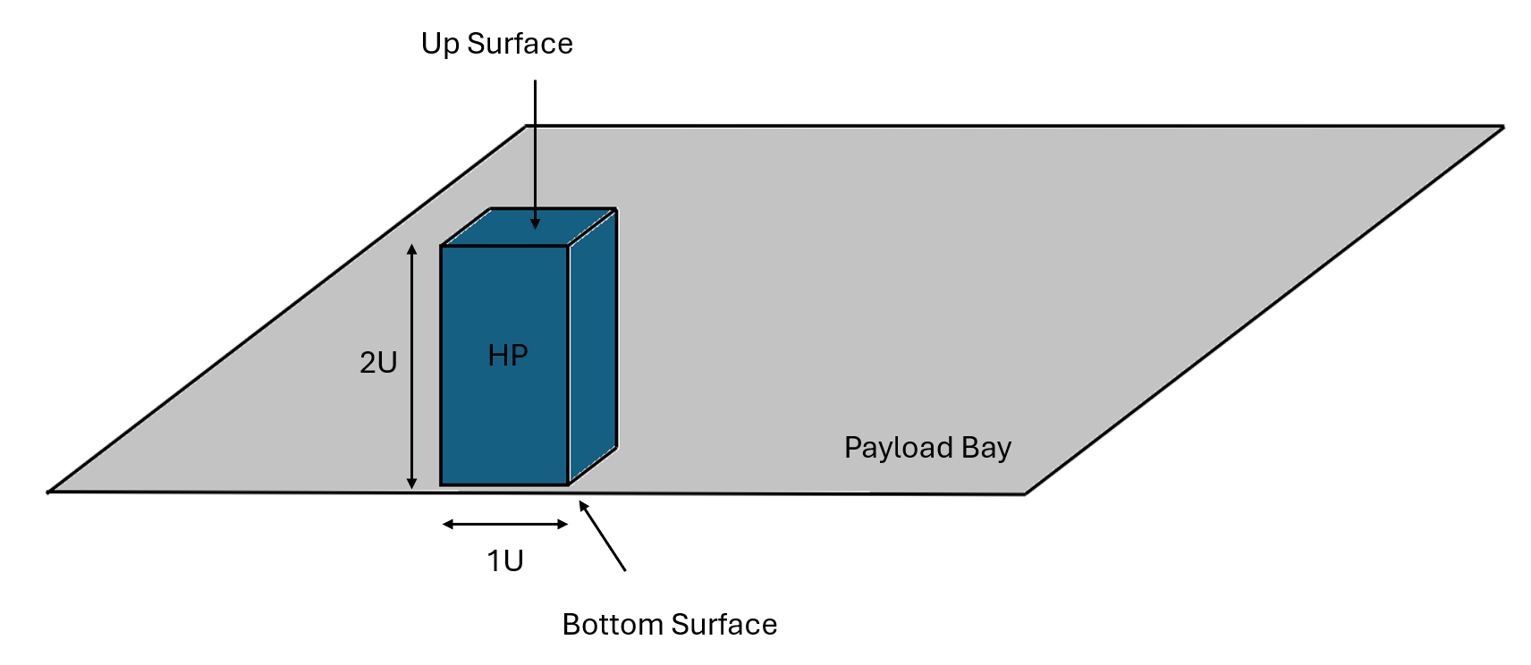
Figure 2: GEN-OPS-09 representation

Structural Requirements
This section defines the structural requirements applicable to the Hosted Payload. These requirements ensure the mechanical integrity and robustness of the payload throughout all mission phases. The section includes constraints related to the mechanical interface with the hosting platform, the characteristics and configuration of interface fasteners, and the verification methods to be applied in accordance with relevant standards [R.D.5][R.D.6].

Req. ID | Req. Detail | Compilance | Value / Compliance rationale
 | The Hosted Payload shall have a minimum number of 4 interface fasteners.
 | The Hosted Payload shall exploit interface fasteners with a length smaller than 10 times their diameter.
 | The Hosted Payload’s fasteners should be verified as per [R.D.6].
Table 5: General, Structural HP requirements

Mission Requirements
Mission requirements define the operational conditions and performance criteria that each Hosted Payload must meet to ensure the successful execution of the mission. These requirements include constraints related to orbit, operational lifespan, availability, reliability, and compatibility with the ION mission profile.

Req. ID | Req. Detail | Compilance | Value / Compliance rationale
The Hosted Payload Operations shall occur on SSO.
*different LEO orbits could be accommodated according to further evaluation.
The Hosted Payload operations shall be performed on an orbit with:
Inclination of Launcher Vehicle Orbit release +-1°.
Nominal reference value is SSO of 500-600 km altitude.
*Change of Orbital Parameters can be accommodated according to further evaluation
The Hosted Payload operations shall be performed on an orbit with:
LTAN of Launcher Vehicle Orbit release +-10 minutes.
*Change of Orbital Parameters can be accommodated according to further evaluation
The Hosted Payload operations shall be performed on an orbit with:
Altitude of Launcher Vehicle Orbit release +-10 km.
Nominal reference value is 480-600 km altitude.
The Hosted Payload operations shall be performed on an orbit with:
eccentricity of Launcher Vehicle Orbit release +- 0,001.
Nominal reference value is circular orbit SSO (e=0).
 | The Hosted Payload shall not require to D-Orbit a Ground segment for autonomous TT&C management.
 | The Hosted Payload operations overall cumulative amount of days shall be up to 1 business month, independently from daily Operations definition (1 day is considered as dedicated to customer independently of how many tests are executed).
The Hosted Payload shall be intended for civil purposes and shall not be used, either directly or indirectly, for:
- Military or nuclear explosive applications;
- Civil nuclear activities not covered by IAEA safeguard agreements;
- The development and/or production of chemical weapons, weapons of mass destruction (WMDs), or missiles intended to deliver such weapons.
 | The Hosted Payload shall not generate a magnetic dipole moment greater than 3 A·m² under any operational condition.
 | The Hosted Payload shall not generate a torque greater than 0.35 Nm for a continuous duration exceeding 15s.
Table 6: General, Mission HP requirements

Operation Requirements
This section outlines the high-level operational framework applicable to Hosted Payloads, with a focus on mission preparation and integration within the hosting platform. The scope is limited to essential pre-launch operational elements, such as regulatory coordination and test planning, which must be addressed within defined timeframes to ensure compatibility with the mission schedule.
Detailed requirements related to these aspects are provided in the following table. Any additional operational provisions will be tailored to the characteristics of the selected mission.
Req. ID | Req. Detail | Compilance | Value / Compliance rationale
 | If the Hosted Payload is equipped with active RF system the Hosted Payload Provider shall autonomously submit ITU licenses at L-6 months.
 | The Hosted Payload OPS Test Plan shall be defined in detail latest by L-4 months.
The Hosted Payload Operations could require pointing control toward Earth:
- Nadir Pointing
- Inertial Pointing

The Hosted payload could potentially requires pointing performance :

- Target pointing (Inertial/Nadir):
  - APE > 7°
  - AKE > 4,84°

Upon D-Orbit evaluation they can be extended to:
- Target pointing (Inertial/Nadir):
  - APE > 3.3°
  - AKE > 1,69°

 | If required, the Hosted Payload shall be pointed with one of the possible pointing for a maximum of 20 minutes.
 | The Hosted Payload operations shall be taskable during nominal operational shift times (9am to 2am Italy timezone).
 | The Hosted Payload operations requests shall be done latest on the Friday of the week before the intended test execution.
 | The payload if equipped of Transmittion system shall not trasnsmit in the S-Band frequency 2200-2900 MHz.
Table 7: General, Operation HP requirements

Software Requirements
Software requirements define the specifications for controlling and managing Hosted Payloads through ION’s boards. These requirements cover aspects such as the software interface between the payload and the hosting platform, communication protocols, and command management.
Req. ID | Req. Detail | Compilance | Value / Compliance rationale
 | The Hosted Payload's On-Board Computer Procedures (OBCPs) shall follow the D-Orbit guidelines that are delivered at L-6 months.
 | The Hosted Payload shall be operated through OBCPs running on the ION boards.
 | The Hosted Payload Provider shall be responsible for the OBCPs development.
 | If Hosted Payload require telemetry parameters from ION, these parameters shall be defined and configured in accordance with the specifications outlined in the OBCP documents.
Table 8: General, Software HP requirements

Electrical, Power and Data Requirements
The electrical interface between the ION and the HPs is implemented through dedicated boards. HPPs are encouraged to use connectors that are compatible with the one mounted on the board, whose specifications are provided in the table below.

Item | Connector Type
ION output to hosted payload | Harwin - M80-4812642
Table 9: ION board connector cable side
In any case, it is mandatory for the HPP to supply the complete technical specifications of the connector installed on the Hosted Payload, as well as those of the mating connector that will be assembled on the harness provided by D-Orbit. The Hosted Payload’s connector must be properly exposed; ensuring proper exposure after integration on the satellite is one of the key drivers in the design or selection of the mechanical interface.

Req. ID | Req. Detail | Compilance | Value / Compliance rationale
 | The Hosted Payload shall not require a memory storage on ION board more than 25 MB.
 | The Hosted Payload daily maximum uplink request shall not exceed 2,5 MB per day, during its operational days.
 | The Hosted Payload daily maximum downlink request shall not exceed 3,5 MB per day, during its operational days.
The Hosted Payload shall present a single data and power connection with the ION board, meaning one unique connector on Platform side is available and one unique command for data activation and for power activation.
- 3 pin AWG 24 for power provisioning
- 1 pin for RS-42 RX+
- 1 pin for RS-42 RX-
- 1 pin for RS-42 TX+
- 1 pin for RS-42 TX-
The Hosted Payload electrical channel shall provide a single voltage value and overcurrent limit protection from the options listed below.
- Voltage: 5/8/10/12/15/20/24 V
- Overcurrent limit protection: 0,5/1/1,5/2/2,5/3 A
The Hosted Payload shall communicate with the satellite through RS-422.
*Variations on the communication protocol can be implemented by evaluating the economic and technical feasibility of the changes required by the platform on a case-by-case basis.
 | The Hosted Payload shall have a baud rate preferably of 115200 and maximum up to 1000000 bps.
 | The Hosted Payload maximum power consumption at stationary shall be below 72W.
 | The Hosted Payload Power profile in terms of power and duration for a single test per day, shall be below the values reported in Figure 3.
 | The Hosted Payload shall not inject current or voltage into the platform’s power distribution system.
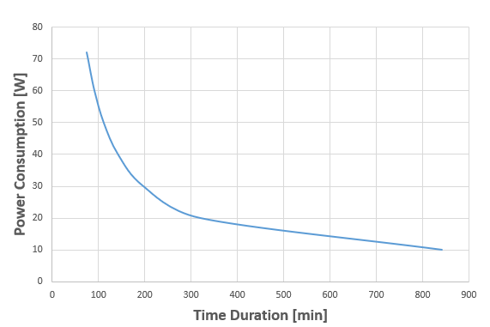
Table 10: General, Electrical, Power and Data Requirements
Figure 3: HP Available power vs Operations time for single test per day

Environmental Requirements
Environmental requirements define the external conditions that Hosted Payloads must withstand throughout all mission phases, including launch and orbital operation. These requirements cover factors such as vibrations, mechanical shocks, acoustic loads, space radiation, and electrostatic discharges.
The goal is to ensure that each Hosted Payload is designed to operate safely and without performance degradation in the space environment and during critical mission phases. Additionally, these requirements ensure compatibility with the environmental stress levels imposed by the hosting platform and the launch vehicle.

Req. ID | Req. Detail | Compliance | Value / Compliance rationale
 | The Hosted Payload active thermal control system design, if any shall be under the responsibility of the HPP respecting the other requirements.
 | The Hosted Payload passive thermal control system design if any shall be under the responsibility of the HPP respecting the other requirements.
 | The Hosted Payload survivability thermal range shall be compatible with the Carrier mission typical thermal range: -30/+70°C.
 | The Hosted Payload operative thermal range shall be compatible with the Carrier mission typical thermal range: -30/+70°C
 | The Hosted The accommodated payload must withstand the loads specified in the Annex 1. Vibration Test Levels.
Table 11: General, Environmental HP Requirements

Verification Requirements
Verification requirements establish the processes, methods, and criteria necessary to demonstrate that Hosted Payloads comply with all required technical, operational, environmental, and safety specifications. These requirements define verification methods, which may include analysis, inspections, functional tests, environmental tests, and compatibility tests with the hosting platform.
The goal is to ensure that each Hosted Payload is properly qualified and validated before integration and throughout its operational phase, minimizing the risk of malfunctions or incompatibilities. Additionally, these requirements define acceptance criteria, required compliance levels, and documentation guidelines for test results, ensuring a transparent and traceable verification process.

Req. ID | Req. Detail | Compliance | Value / Compliance rationale
 | The Hosted Payload shall be available in EM or PFM/FM item at L-5.5 to perform Hardware In-the-Loop (HWIL) Test with ION EM board.
 | The customer shall attend EM Test at D-Orbit Headquarter in Fino Mornasco, Italy.
 | The Hosted Payload PFM/FM shall be available at L-5 for Integration to platform.
Electrical, data and SW interfaces test with PFM/FM shall be performed:
- After integration of the PLD
- After vibration testing session
- After TVAC testing session
- At Launch Base
The Hosted Payload PFM/FM shall be tested adopting an integrated-testing approach, i.e. the FM shall be integrated on ION FM and it shall undergo testing campaign with the satellite, for the following tests:
- Sine Burst test
- Sine test
- Random Vibration test
- TVAC test
The HPP shall take into account and ensure compliance with the documentation provided by D-Orbit, as listed below.
- This document [R.D.12]
- Documents reported in Annex “5.5” Main Events
- Figure 4 ION and HP (hosted payload) AIV-AIT High level Plan
The HPP is required to develop and deliver, at minimum, the following documentation to D-Orbit in support of mission preparation and execution:
- IRD (Annex “5.5” Main Events)
- IRD – Annex 2 (Annex “5.5” Main Events)
- IRD – Annex 5 (Annex “5.5” Main Events)
- Documents reported in Annex “5.5” Main Events
Table 12:General, Verification HP Requirements
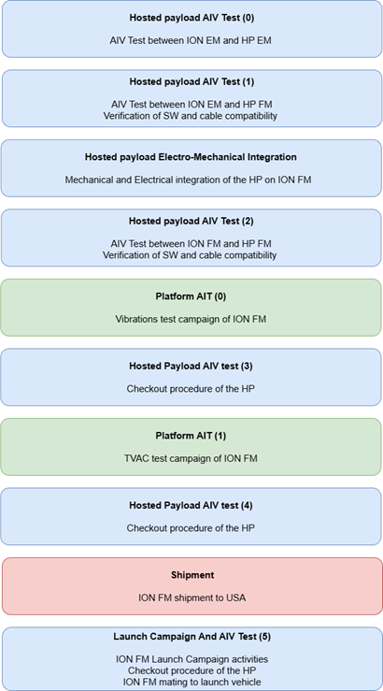
Figure 4 ION and HP (hosted payload) AIV-AIT High level Plan

Product Assurance Requirements
This section defines the Product Assurance (PA) requirements applicable to all HPs intended for integration on the ION platform. These requirements aim to ensure compliance with international standards, launcher constraints, and operational safety and reliability throughout the lifecycle of the payload, from design to in-orbit operation.
The topics covered include regulatory compliance (e.g., Space Debris Mitigation, ITU regulations), material compatibility (e.g., forbidden materials, outgassing, corrosion protection), mechanical and process-related requirements, handling and testing procedures, contamination control, storage and transportation, as well as launcher interface constraints and in-flight behavior.
These requirements establish a common framework that all Hosted Payload Providers are expected to consider and comply with throughout the preparation, integration, and verification phases, ensuring compatibility with mission objectives and applicable standards [R.D.7].

Req. ID | Req. Detail | Compilance | Value / Compliance rationale
The Hosted Payload shall comply with the Spacecraft Debris Mitigation Policies
- ISO 24113:2023
- ESA Zero-Debris Policy (Applicability for the respective regions of interest)
 | The Hosted Payload shall be compliant to launcher vehicle's user manual [R.D.4].
 | The Hosted Payload shall be compliant to LST-000232 Payload Forbidden And Restricted Materials List [R.D.2].
Each individual non-metallic material used in flight hardware or ground hardware that will be exposed to vacuum shall satisfy at least one of the following criteria for Recovered Mass Loss (RML) and Collected Volatile Condensable Material (CVCM), when tested per [R.D.3]:
- RML ≤ 1.0%, CVCM ≤ 0.1% (any condition for surface exposition).
- RML ≤ 3.0%, CVCM ≤ 0.1% (with exposed area < 2 in2).
- RML > 3.0%, CVCM > 0.1% (with exposed area < 0,25 in2).
 | Mechanical parts and materials with hazardous characteristics shall be identified and managed via the Critical Items List, identified as Safety Critical Items.
When present on the Hosted Payload, austenitic and ferritic stainless steel surfaces shall be passivated.
Note 1: Passivation of stainless steel surfaces removes embedded debris from machining and forming operations, such as ferrite particles that can initiate corrosion in the underlying material.
Note 2: The requirement applies also to off-the-shelf fasteners.
All mechanical parts, assemblies and equipment, including spares, on the payload shall be finished to provide protection from corrosion.
This applies equally to fasteners and other fixing devices, such as insert systems.
 | The Hosted Payload Provider shall provide Payload Declared Materials List (PDML) and Payload Declared Processes List (PDPL) by mean of the provided templates and their instructions. [R.D.10], [R.D.11]
 | The Hosted Payload Provider shall communicate any functionality of the Hosted Payload that might cause communication interference between ION and other co-payloads or ground.
 | If testing on Hosted Payload's communication subsystem is required, it shall be operated in transmission mode without leaving antennas radiating in free-space to avoid operators' exposure to hazardous electromagnetic fields. Note: X-band antennas properties shall be verified at equipment level only according to relative specification.
The Hosted Payload shall be designed to withstand D-Orbit cleanroom ISO 8 storage conditions for at least 1 year after delivery and, in general, for the complete stay at the facility.
NOTE: Cleanroom storage conditions are: Temperature 22*C ± 3*C; Positive minimum pressure delta: Between cleanroom and surrounding area: 1.2 mm H2O (12 Pa); RH 55% ± 10%.
The Hosted Payload shall undergo the Acceptance campaign in a fully integration configuration with the platform.
NOTE: The Acceptance Campaign baseline is considered to be the most strict considering launchers vehicle's user guidelines.
 | The Hosted Payload Provider shall evaluate any need to train D-Orbit personnel in case of critical procedures on the customer's payload.
 | The Hosted Payload Provider shall disclose to ION Product Assurance Manager any Non-Conformance of the Hosted Payload that result in a discrepancy with respect to the payload characteristics (design, processes, MAIT, functional…) formalized by the contract.
 | Non-flight items (RBF, savers, etc.) shall be clearly identifiable with respect to flight items.
 | The Hosted Payload Provider shall communicate any safety provisions (ESD, PPE, cleanliness) that D-Orbit operators need to implement when dealing with Hosted Payload AIT.
 | After Acceptance campaign, the Payload parts shall not be unmounted as baseline operation. Any possible unmounting need due to Non-Conformances shall be addressed during NRB.
 | The Hosted Payload shall embed a Safe Mode, allowing it to isolate from the platform. In any case the payload status could jeopardize the platform or other copayloads mission, the payload shall enter Safe Mode.
 | The Hosted Payload Provider shall guarantee that the payload does not affect ISO 8 Cleanroom cleanliness conditions provided at D-Orbit facilities. This shall be valid from incoming acceptance, unpackaging, integration and testing.
 | Packaging, shipping and storage requirements shall be issued in order to assure required protection to the payload outside Clean Room environment.
Table 13: General, PA HP Requirements

Hosted Payload Class
The following section outlines the classes of HPs considered for the IOD/IOV mission onboard the ION platform. These categories have been identified in the context of this initiative to represent the types of technologies eligible for flight opportunities. The classification is based on the primary objectives and functionalities of the payloads, ensuring consistency with the mission’s framework and compatibility with the hosting platform.
These classes are defined to categorize payloads based on their intended purpose and core functionalities, reflecting the nature of the technology demonstration and its alignment with mission objectives.
Req. ID | Req. Detail | Compliance | Value / Compliance rationale
Hosted Payloads eligible for selection shall belong to one of the following classes:
- Radiation and Shielding
- Power generation and management
- Attitude control
- Communications
- Artificial Intelligence
- EEE components and On-board Sensors
- Imaging technologies
- Materials
Table 14: General, HP Classes Requirements

Radiation and Shielding
Payloads designed to study the effects of space radiation, test radiation-resistant components, or develop shielding technologies to protect electronic systems.

Power Generation and Management
Payloads focused on developing technologies for power generation, storage, or management in space, excluding systems with integrated batteries (*).
(*) Unless the batteries themselves are the subject of the IOV/IOD activity. In such cases, onboarding may be allowed according to further evaluation, considering the limits due to hazardousness and explosive materials subjected to RPUG prescriptions.

Attitude Control
Payloads designed to modify the satellite’s attitude, enabling it to change its orientation or stabilize itself in space. Within this class are also propulsive payloads.

Communications
Payloads designed to test communication technologies, improve data transmission in space, or study signal propagation in orbit.

Artificial Intelligence
Payloads integrating artificial intelligence algorithms for onboard data processing and, optimization of space operations.

EEE Components and On-board Sensors
Payloads designed for testing electronic components qualified for space environments or developing sensors for monitoring orbital conditions and mission operations. Within this class are also quantum and photonics and, robotics payloads.

Imaging Technologies
Payloads designed for image acquisition for scientific, technological, or application purposes, using optical, multispectral, or hyperspectral sensors.

Materials
Payloads designed for testing advanced materials in space environment (compliant to [R.D.2]).

CONCLUSIONS
Compliance with the requirements outlined herein is a necessary condition for mission eligibility and successful missionization, ensuring safe, efficient, and goal-aligned integration with the ION platform.

Annex 1. Vibration Test Levels
The present section reports Random and Sine Vibration Test Levels required for SpaceX Transporter missions. Levels are retrieved considering Maximum Predicted Environment (MPE) from the RPUG and adding the effect of ION Frequency Response Function (FRF). For those frequencies where the Satellite's FRF decreases the load, the MPE value was considered.
In the following, Lateral refers to ION X and Y axes, while Longitudinal refers to ION Z axes.
The Test Levels may vary according to the specific mission.

RANDOM LOADS
Adopting the Flight Unit Protoqualification (also referred as PFM in the following) approach implies the following test requirements:
- PFM Duration: 01 min/axis
- PFM Repetition: 1 time per axis
Protoqualification Loads are reported in Figures below

- Random Lateral
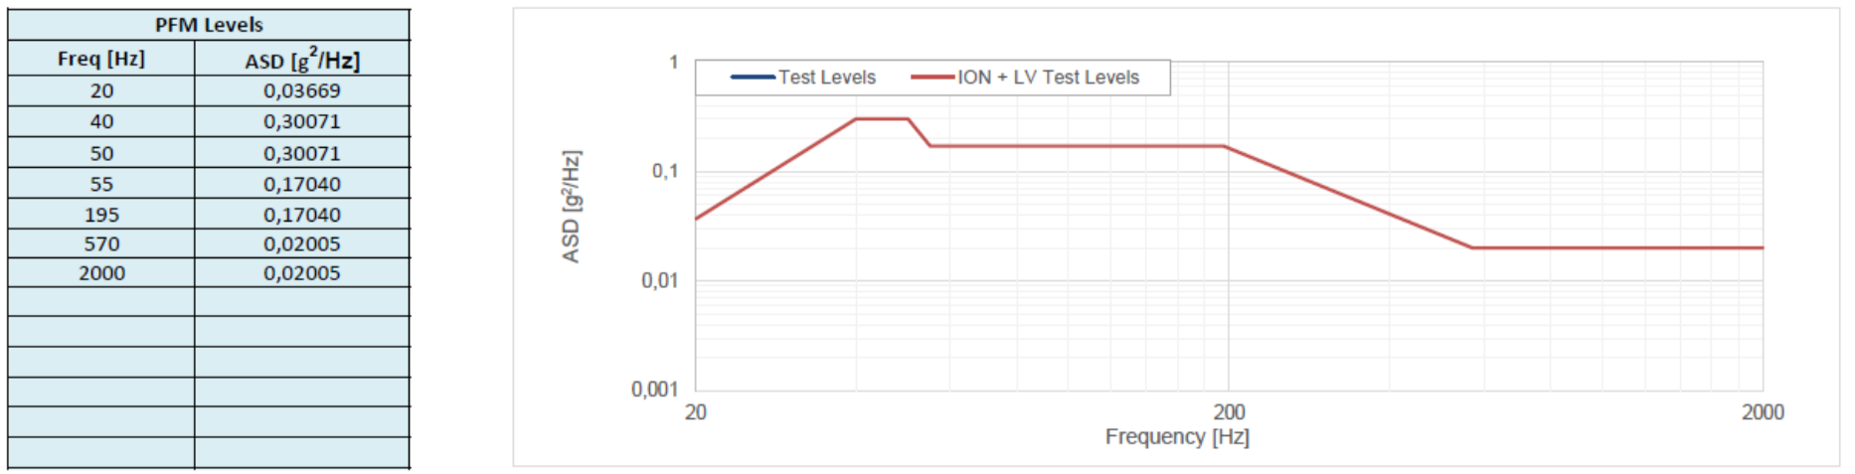
Figure 5: Protoqualification Random Lateral Vibration Test Levels

- Random Longitudinal
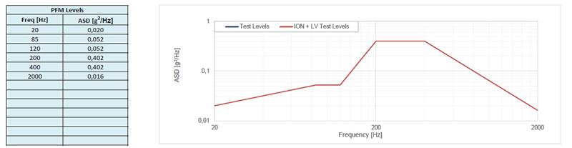
Figure 6: Protoqualification Random Longitudinal Vibration Test Levels

SINE LOADS
Protoqualification Loads are reported in figures below
- Sine Lateral
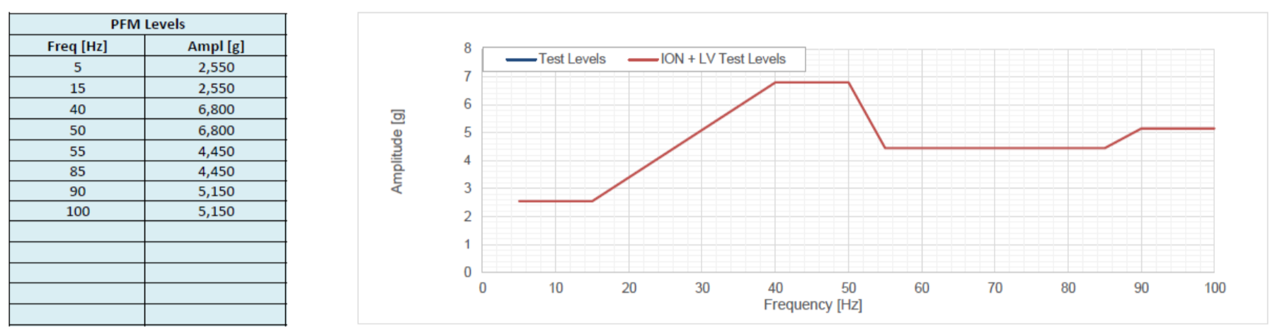
Figure 7: Protoqualification Sine Lateral Vibration Test Levels

- Sine Longitudinal
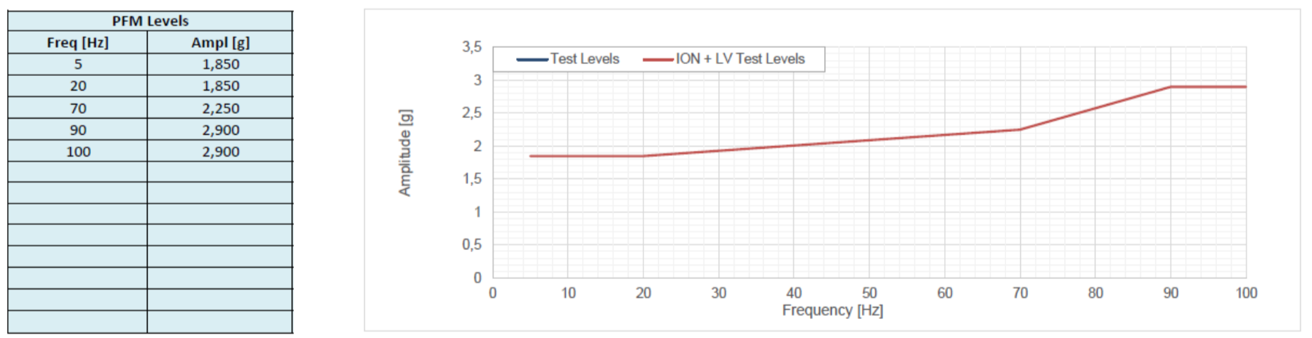
Figure 8: Protoqualification Sine Longitudinal Vibration Test Levels

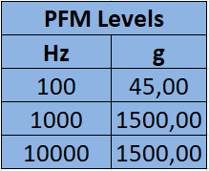
SHOCK LOADS
Figure 9: Protoqualification Shock Test Levels

Annex “5.5” Main Events
Are next reported all the deliverables expected to be provided by the Payload Provider during the entire Mission Process, in function of the phase of the mission itself expressed as “L-X” “Months (X) before the Launch (L)” deadlines. Each Hosted Payload mission preparation can be customized based on its specific requirements, but the early start and late finish integration and testing activities are dictated by platform schedule and LVP deliverables calendar. Documents and L-X deadlines may vary according to the specific launcher mission.

5.5.1 Before Kick-Off meeting
Before the KO meeting, the deliverables presented in the following sections shall be officially provided by the HPP to D-Orbit.

5.5.1.1 Payload CAD Model & Drawings
HPP shall provide the CAD Model and Drawing in compliance with one of the following formats:
The CAD model shall be representative of the followings:
- Payload external envelope: needed to perform Hosting Structure Selection, a proper fit-check, mechanical integration compatibility
- Payload mass properties: in terms of:
  - Payload mass;
  - Payload CoG position with a well-defined reference frame;
  - Payload Inertias with respect to well defined reference frame (could be either the same used to define CoG position or the one located in the CoG itself, no other allowed).
- Payload IBF-RBF: If payload is provided of IBF/RBF, the CAD model shall report position.
- Payload Connectors and Harness: the CAD model shall show dimension and position of connectors to be plugged toward the Platform; If Payload is equipped with Harness and connectors protruding from the main body a representative Volume shall be allotted in the CAD
- Payload surfaces/points requiring accessibility: if the Payload is equipped with systems requiring direct access toward outer space, such as cameras or sensor

5.5.1.2 Hosted Payload IRD
The HPPs shall provide general information regarding their HPs in accordance with the requirements and parameters specified in the [R.D.12]. The provided information shall include, but is not limited to, key physical, electrical, thermal, and operational characteristics of the HP. This data is essential to verify compliance with applicable constraints, to properly configure the ION platform, to ensure compatibility with other hosted payloads, and to support mission planning and customization activities. In this phase, D-Orbit requires the following documents to be completed:
- IRD
- IRD – Annex 2: contains information with respect to HP volume and the mass properties of HP.

5.5.2 Mission Kick-Off meeting
The first milestone following the assignment of a Hosted Payload to a mission is the Kick-Off (KO) Meeting. During this meeting, the mission team is formally introduced, including the Mission Manager—serving as the main point of contact for all programmatic aspects and interactions with the Launch Vehicle Provider (LVP)—and the Payload Engineer, who acts as the technical point of contact and will support the Hosted Payload Provider throughout all technical aspects of the mission, such as the definition of the interfaces with the platform.

5.5.2.1 Mission Official Schedule
D-Orbit shall provide an updated schedule of the Mission deadlines, based on the Launch opportunity agreed with the HPP. The HPPs shall be responsible for completing and submitting all required documentation intended for the Launch Provider, ensuring full responsibility for the accuracy and compliance of the information provided. Additionally, the HPPs shall compile all necessary documentation to demonstrate compatibility with the launch service requirements, applicable policies, and regulatory authorities (such as ITU, NOAA, and others as relevant). All associated delivery dates for these documents will be included and detailed within the Mission schedule provided by D-Orbit.

5.5.2.2 Software Development Kit
D-Orbit shall provide a Development Kit, referred to as the 'SDK', which consists of a board simulating the ION platform’s software and hardware environment. The Kit is entirely developed and produced in-house by D-Orbit. The SDK units are already available in stock and require only configuration prior to shipment to the customer, which is carried out following the KO meeting.
The SDK will be delivered to the HPP to enable the development of its own On-Board Control Procedures (OBCPs), intended to be uploaded to the ION On-Board Computer (OBC). This is applicable only to Hosted Payloads.

5.5.3 L-8 and L-6.5 Months Deliverables
This section outlines all deliverables that the HPP is required to deliver to D-Orbit by L-8 and L-6.5, in order to ensure the correct submission of all platform and HP documents.
It also includes the documentation that the HPP must complete and provide to enable the correct planning and execution of mission-critical operations related to the HP, in compliance with the mission’s technical, operational, and safety requirements.
All deliverables for the LVP will be collected and submitted by D-Orbit and are listed below with the end user for whom the document is intended specified in brackets:

- Payload Configuration Worksheet (LVP) (L-8)
- Payload Environmental Test Approach & Schedule (LVP) (L-8)
- Payload Transmitter Verification Worksheet (LVP) (L-8)
- Program Introduction (LVP) (L-6.5)
- Rideshare Range Safety Checklist (LVP) (L-6.5)
- Pinout Definition (D-Orbit) (L-6.5)

5.5.4 Physical delivery, payload OBCPs and EM/FM test
Preliminary tests on the ION EM can be performed as soon as the HP is delivered to the D-Orbit facility in Fino Mornasco and must be completed no later than one month before the vibration test of the platform. For the tests to be carried out correctly, the OBCPs must be completed before the tests begin.
Typically, this provides a testing window spanning approximately 14 weeks, from the initial Kick-Off meeting to the test on the Engineering Model (EM), corresponding to the L-9 to L-6.5 time frame.
Throughout this period, the schedules of both the platform and the customer’s Experiment may run in parallel, affording optimal flexibility regarding the specific test dates.
Engineering model (EM) testing
D-Orbit will allocate two days for the Experiment Provider to access both its testing facilities and the platform’s Engineering Model. The Payload Engineer will support and guide the execution of these tests, ensuring they are conducted according to the mission requirements and technical specifications. Testing requirements, defined in the preceding months, are intended to replicate the HP’s in-orbit functions as accurately as possible. HPP will have to fill out a form provided by D-Orbit with all the specifications of the tests to be performed, called the “AIV Plan”. Accordingly, during this testing phase, the HP will receive the predetermined power level necessary for proper operation and will be connected to an Engineering Model On-board Computer (OBC) which will run a custom application developed by the HPP. This assures a complete customization of the tests as long as the said tests remains inside the agreed technical requirements and the execution timeframe.
Additionally, the customer will be responsible for providing an Onboard Control Procedure (OBCP) capable of independently assessing the HP’s health status, separate from any operational simulation applications. This health-check application will be utilized before and after each test series on the platform, as well as to verify the Experiment’s status following any shipment.
Flight model (FM) testing
Testing on the Flight Model (FM) will occur within a shorter timeframe. This testing schedule can be adjusted within a one-month period, with the earliest start set for one week after the EM testing and the latest completion required one month before the submission of Test Reports for the Launch Vehicle Provider (LVP). During these FM tests, D-Orbit will once again provide engineering support; however, the HPP’s participation will be remote. This test phase is designed to be brief, not exceeding four hours in total, and will consist of health checks and functional testing.
Flight model (FM) testing after environmental test campaign
Following the completion of the full satellite-level test campaigns, including vibration and thermal vacuum (TVAC) testing, and after the platform’s transfer to the launch site, a dedicated test session will be conducted for all integrated HPs. This verification phase will allow for the assessment of payload status and, in the event of any anomalies or malfunctions, will support the identification of the critical phase responsible, enabling targeted analysis and corrective actions.
5.5.5 L-4 Deliverables
As in section 5.5.3, below are the deliverables that HPP is required to deliver to D-Orbit by L-4.
All deliverables for the LVP will be collected and submitted by D-Orbit and are listed below with the end user for whom the document is intended specified in brackets:
- AFSPCMAN 91-710 tailoring (if required) (LVP)
- Certification Data for Hazardous Systems (if required) (LVP)
- FAA Payload Review Information (LVP)
- Environmental Test Report (LVP)
- IRD – AIV Plan (D-Orbit)
- IRD – Annex 5: contains information regarding HP operations to be carried out in orbit. (D-Orbit)
5.5.6 L-2.5 Deliverables
As in section 5.5.3, below are the deliverables that HPP is required to deliver to D-Orbit by L-2.5.
All deliverables for the LVP will be collected and submitted by D-Orbit and are listed below with the end user for whom the document is intended specified in brackets:
- AFSPCMAN 91-710 Compliance Letter (LVP)
- Payload Insurance and Waiver(s) of Subrogation (LVP)

5.5.7 L-2 Deliverables
As in section 5.5.3, below are the deliverables that HPP is required to deliver to D-Orbit by L-2.
All deliverables for the LVP will be collected and submitted by D-Orbit and are listed below with the end user for whom the document is intended specified in brackets:
- Payload In-Orbit Licenses (LVP)
- Payload Insurance and Waiver(s) of Subrogation (LVP)

